Community of Hope PO Box 1253
Melbourne, FL 32902

321-474-0966
build@hopeofbrevard.com

Request for Proposals Construction of Multifamily housing project

Hope Hammock
The Community of Hope invites construction firms to submit proposals to perform construction of an upcoming capital project at 550 S. Brown Ave., Titusville, Florida

Pre-Proposal meeting: held via TEAMS on Tuesday April 9th, 2024 at 10:00 AM.
Interested contractors are encouraged to attend. Meeting is non-mandatory.
Join on your computer, mobile app or room device
Click here to join the meeting
Meeting ID: 274 843 940 330
Passcode: S6yxfm

Submission Deadline: Tuesday April 16th, 2024 at 4PM

Deadline for final submission of questions: Friday, April 12th, 2024 at 3 PM
Anticipated Completion Date: March 1, 2025

See also the following attached items:

Special Provisions of the American Rescue Plan Act.

Architectural Drawings as Submitted for Phase II Permit.

Scoring Rubric to be used is selection process.
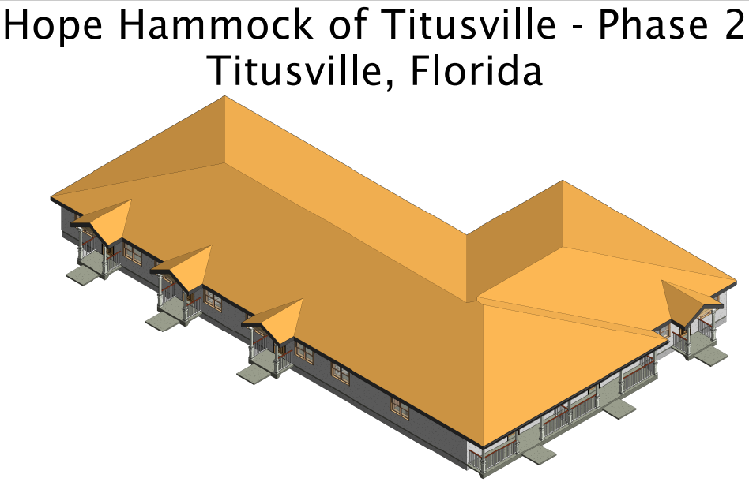

Introduction
The scope of work is the construction of a six (6) unit multifamily structure as Phase II of the Hope Hammock of Titusville Complex. The adjacent Phase I structure and the majority of the site work has been completed and accepted by the owner and the city. Funding for Hope Hammock Phase II is provided by grants from the City of Titusville and Brevard County.

Community of Hope is a 501(c)3 that provides housing for homeless families with children.
This RFP is for Phase II. Phase I (Seen Below) is already built on the site.
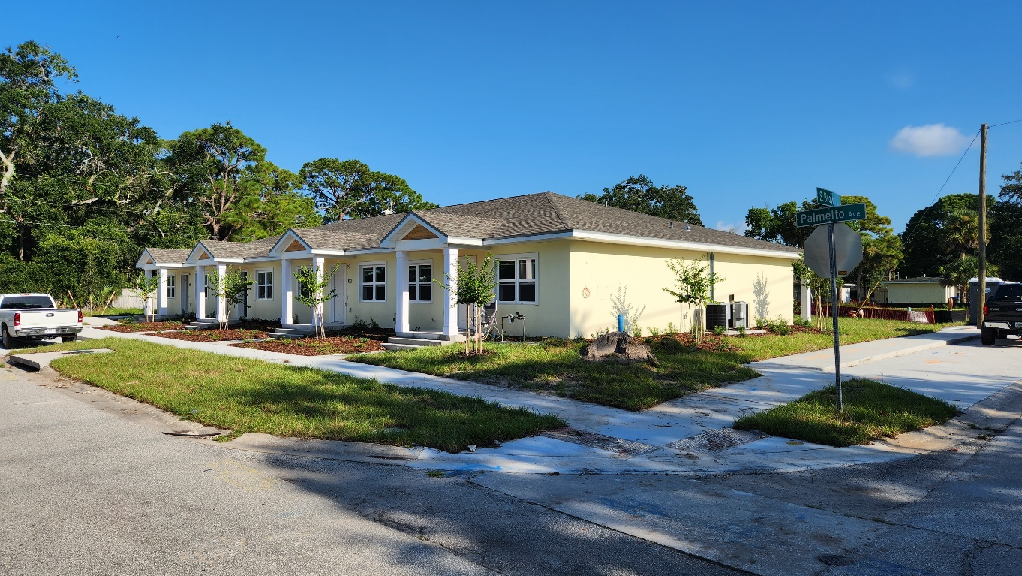

Owner is:

Community of Hope. Mailing address is PO Box 1253, Melbourne, Florida 32902-1253 Office is at 4515 S. Babcock Street, Palm Bay Florida, 32905

FL Tax Exempt ID: 85-8013587337C-6 Federal Tax Exempt: 42-1668898

Consulting Civil Engineers Inc. CCEI has prepared site plans which the City of Titusville has reviewed and approved. CCEI can be reached at 321-269-9930 or sid@cceifl.com.

Tsark Architecture, LLC is the Architect for this project and a building permit is already in process for the six (6) unit building comprising phase II. Tsark Architecture can be reached at 321-241-6378 or greg@tsarkarchitecture.com.

The City of Titusville and Brevard County are providing funding for this project.

The selected contractor for this assignment is required to perform all of the responsibilities of the general contractor and complete all of the construction of Phase II of this complex. They include but are not limited to the following services:
Construction Phase
- Provide full-time field coordination
- Support status meetings with Brevard County and the City of Titusville
- Manage all subcontractor’s activities in the field
- Provide cost estimating services as required
- Construction scheduling
- Document any “as built” approved changes as redlines to the construction drawings. Construction Phase contractor is coordinate with the Florida Certified site surveyor during the construction process to provide accurate As-Built drawings and subsequent legal and sketches that meet the City and/or County requirements.
- Conduct all progress meetings
- Prepare monthly status reports to the Owner
- Review the trade contractors’ safety programs.
- Track and review permits and approvals
- Minimize schedule disruptions
- Coordinate the Owner’s occupancy requirements
- Coordinate all close out documentation

Background
Community of Hope is a 501(c)3, tax exempt non-profit established in 2005. Our mission is housing for homeless families with children. Currently the organization has 52 housing units and manages 3 housing initiatives: Safe Overnight Stay (SOS), Transitional Housing and Permanent Supportive Housing. The organization’s growth comes from local churches, a volunteer Board of Trustees and generous community support. A complete history is available on our website www.hopeofbrevard.com

Questions
Submit questions in writing by email solely to Build@hopeofbrevard.com on or before April 12th, 2024, 3 PM.

The Community of Hope will not interpret bid documents (drawings, et al).

Community of Hope will answer all questions within 2 business days via email. We will share all questions and answers with all bidders. All prospective proposers are encouraged to visit the site and make any required observations of the existing site conditions that could affect their bid. As-built drawings of the completed Phase I site work that have already been approved by the city are available for review.

Owner Provided Documents Support Documents

Site plan - Consulting Civil Engineers Inc. 190225 - Cover Sheet
CD101 – Existing Site Demolition and Erosion Control Plan CS-101 – Site Development Plan
CG-101 – Site Grading and Drainage Plan CU-101 – Site Utility Plan
CS-401 – Site Details
CG-401– Drainage Section CG-402 – Drainage Sections LA-1 - Landscape Plan
As Built Drawings

Architectural Drawings – Tsark Architecture, LLC G101 – Cover Sheet
G102 – General Requirements A001 – Project Specifications A101 – Life Safety Plan
A102 – Dimensions Plan A201 – Floor Plan
A202 – Partition Types A203 – Roof Plan
A301 – Reflective Ceiling Plan A401 - Building Elevations A402 -Building Sections
A501 - Sections and Details A701 - Large scale Plans A702 – Interior Elevations Amendment A702-01
A703 – Millwork sections and details A801 – Finish Plan
A901 - Schedule of Openings A902 - Door Hardware
S101 –Structural General Notes S201 - Phase II Foundation Plan S202 –Foundation Details
S203 – Misc. Details S204 – Misc. Details S205 – Misc. Details
S206 - Roof Truss layout ----------
Mechanical Design – Construction Engineering Group
M1 – Mechanical Specifications, Notes and Details;
M2 - Mechanical Plans:
P1 – Plumbing Specifications, Schedules and Details:
P2 – Plumbing Plan
E1 – Notes Symbols Risers and Schedules:
E2 – Site Electrical Plan:
E3 – Unit Electrical Plan:

Specifications:
Refer to Architectural, Civil, Landscape Plan, and Mechanical design drawings for specifications.

Engineering
All structural, mechanical, electrical and plumbing engineering have been completed for the project. Architectural plans will be sent by email upon request.

Permitting & Inspections
A City of Titusville Construction Permit has been or will be obtained by Architect and/or Owner prior to construction start. There is no anticipated delay in the proposed construction start date due to permitting.

City of Titusville and Brevard County Board of Commissioners have approved this project.

The selected contractor is responsible for all required construction trade permits and inspections.

Pricing:
Prices shall be based on a lump sum amount and include FOB Destination, all packing, handling, shipping charges, fuel surcharges and delivery unless otherwise indicated. The contract will be awarded to the highest rated applicant among those meeting the requirements and fully responsive to the proposal. Alternate bid prices shall not be considered in the initial determination of lowest bid, but will be used, if so desired by the owner, in the final lump sum agreement made with the selected contractor.

PROPOSAL REQUIREMENTS

The respondent’s proposal shall include the following:

- Title page showing the proposal is for construction of Phase II Hope Hammock; the firm’s name, name, address and telephone number of a contact person, and the proposal date.

- Table of Contents

- Information described in the Proposal Format Section as outlined below.

PROPOSAL FORMAT

Company Profile
This section should state the firm size, the type of firm, firm background, the location of the office responsible for this project work.

The firm must attest that it has not:
- been debarred, suspended, proposed for debarment, declared ineligible, or voluntarily excluded from covered transactions by any Federal, State or local Department or agency:
- within a three-year period preceding this proposal, been convicted of or had a civil judgment rendered against them for commission of fraud or a criminal offense in connection with obtaining, attempting to obtain, or performing a public (Federal, State, or local) transaction or contract under a public transaction; violation of Federal or State antitrust statutes or commission of embezzlement, theft, forgery, bribery, falsification or destruction of records, making false statements, or receiving stolen property;
- presently indicted or otherwise criminally or civilly charged by a governmental entity (Federal, State, or local) with commission of any of the offenses enumerated in paragraph 2 above
- within a three-year period preceding this application/proposal, had one or more public transactions (Federal, State, or local) terminated for cause or default

Responding firms should have a minimum of five years of experience providing professional construction services as described in the RFP.

Proposed Staff
Indicate the proposed team organization and identify key personnel including the project manager and field superintendent. Please include resumes for all key staff, outlining their roles on similar projects.

All staff must be certified as able to work legally in the United States by e-verify or other documented means (I-9)

Provide the name and contact information for the official contact person for the contract. (ie contract manager, project manager or field superintendent)

References
Each bidding contractor is required to provide three (3) reference projects of similar building type, scope and size completed in the past five (5) years, including contact information for each project’s owner or owner’s representative. Contact information shall include current phone numbers and email addresses.

Project Schedule
Submit a proposed construction schedule with a completion date set for March 1st, 2025.

Submission Requirements
Submit an itemized bid to provide their proposed bid contract value, their proposed alternative values and their justification for alternatives. Each bidding contactor is required to submit a schedule of values for their proposed base bid contract value.

Proposals are to be submitted by the deadline.

Alternatives
Bidders shall include alternative pricing on their bid forms. The owner reserves the right to accept or reject alternatives.
Alternate materials shall be listed on the Schedule of Values (See Attachment A) Examples of Alternatives
Item | Price/ unit | Bid | Alternate Material | Price/unit | Bid | Notes
Ceramic Tile drawing  grade | $$$ | $$$ | Ceramic Tile lesser grade | $ | $
Refrigerator  with icemaker | $$$ | $$$ | No icemaker | $ | $ | Would leave line for future
Porcelain tile | $$$ | $$$ | Ceramic Tile | $ | $
Cultured Marble sink | $$ | $$ | Laminate with inset  sink | $ | $ | $
Dishwasher | $$$ | $$$ | Cabinet | $ | $ | Would install outlet for future
Hurricane windows | $$$ | $$$ | Hurricane Windows  alternate source | $ | $ | Hurricane Shutters are not  viable alternative

Bid Compliance Form
Each bidder shall complete and submit a bid compliance form - Attachment B

Submission Procedure
Ensure Community of Hope receives proposals and supporting bid documents by email, US mail, Courier or in person no later than the deadline given above. Proposals received after the deadline of April 16th, 2024 by 4:00 PM will not receive consideration.

Mailing Address Community of Hope PO Box 1253
Melbourne, FL 32902-1253

Office: (In Habitat Restore Building) Community of Hope
Office 6
4515 S. Babcock Street Palm Bay, FL 32905

Email Build@hopeofbrevard.com

Submit electronic submission with bid, reference projects and contractor’s proposed schedule in Adobe Acrobat PDF format. Formatted all submissions to print on 8 ½ X 11 letter sized paper

Proposals must state that bids are valid for at least forty-five (45) days. Send electronically submitted proposals return receipt requested.
Any submitted physical proposals shall be in an opaque envelope and marked:
Request for Proposal (RFP) for Hope Hammock Phase II and include the bidder name and address.

Bids not prepared and/or submitted in accordance with the provisions hereof are incomplete and will not be considered. Community of Hope reserves the right to waive irregularities and to reject any or all bids. Community of Hope reserves the right to negotiate with the selected bidder in the event that the price exceeds the projected cost estimates.
Any bid may be withdrawn prior to the above scheduled time for review of bids. Any bid received after the time and date for submittal of bids shall not be considered.

Additional Contract Requirements

Modification of Bids
Modifications to bids already submitted will be allowed if submitted in writing prior to the bid date and time noted in this Request for Proposals.

Evaluation and Contracting
All proposals satisfying the requirements of this Request for Proposal will be evaluated to establish which of the bids best fulfills the needs of Community of Hope and this project. Community of Hope anticipates entering into a contract with the successful bidder to execute the proposed work.

Note that Community of Hope is not legally obligated to select the lowest bid. Community of Hope reserves the right to select the contractor they deem the best fit to perform this work and best able to fulfill the interests of Community of Hope. Community of Hope will review all submitted proposal materials prior to selecting a contractor for this project.

This Request for Proposal does not commit Community of Hope to award a contract, to pay any costs incurred in the preparation of a proposal. All proposals upon submission become property of Community of Hope. Community of Hope reserves the right to accept or reject any or all proposals received as a result of this request, to negotiate with all qualified offerors or to cancel this Request for Proposal, if it is in the best interest of Community of Hope.

Forms of Agreement
Community of Hope anticipates using AIA A101-2017 – Standard Form of Agreement between owner and Contractor where the basis of payment is Progress Payments for this project. The contractor will have an opportunity to purpose acceptable alterations to this agreement.

Disbursements
Contractors shall use AIA G702 Application and Certificate for Payment. and AIA G703 Continuation Sheet to the G702.

The schedule of values for the project will transfer to the G703 Continuation Sheet and be used for requesting monthly disbursements. Requisitions shall be based on the schedule of values.

Guarantee, Service Contract and Warranties
The successful bidder will be required to guarantee that all work, including any and all labor and materials, shall remain free of defects for one (1) full year after project completion. Manufacturer’s warrantees on all MEP equipment and other Architectural Warranties shall be collected and submitted to the Owner for their record and possible future use.

Insurance Requirements
This project requires the contractor and major subcontractors to have proof of General Liability Insurance, Auto and Worker’s Compensation insurance as required by the State of Florida, and Builder’s Risk Insurance for the project.
If off site storage is required to meet project time needs, insurance for off-site locations is required. Photo evidence of material procured for the project is also required with proof of insurance when requesting payment for stored materials.
The General Contractor awarded this project must provide proof of insurance at contract signing.

Performance and Payment Bonds (Letter of Credit)
Each bidder shall furnish a performance bond covering the complete execution of the project according to the contract documents and a payment bond covering payment of any and all obligations associated with the project. The cost of these shall be identified in the bid.
Proof of bonding is required at contract signing.

Federal Requirements - Section 3
The work to be performed under this contract is subject to the requirements of Section 3 of the Housing and Urban Development Act of 1968, as amended, 12 U.S.C. 1701u (Section 3) and the contractor and subcontractors must agree to comply with HUD’s regulations in 24 CFR part 75. The purpose of Section 3 is to ensure that employment and other economic opportunities generated by HUD assistance or HUD-assisted projects, shall, to the greatest extent feasible, be directed to low-and-very low-income persons, particularly persons who are recipients of HUD assistance for housing.

Other Federal Requirements
The contractor and any subcontractors will be required to comply with all applicable Federal requirements of 24 CFR 92 Subpart H and 24 CFR 5 Subpart A and the nondiscrimination requirements of section 282 of the Act. This includes, but is not limited to, compliance with the drug-free workplace requirements of 2 CFR 2429, Fair Housing Act (42 U.S.C. 3601-20) and implementing regulations at 24 CFR 100, Civil Rights Act of 1964, Executive Order 11246 - Affirmative Action and Equal Employment Opportunity, Executive Order 11625 and 12432- Minority Business Enterprise, Executive Order 12138 – Women Business Enterprise and Copeland Anti-Kickback Act.

Appendix A – Schedule of Values See Project documents for this in Excel form
 | Items are given as examples - Form is to be modified to meet specifics of Hope Hammock Phase II
 | List is not inclusive | Items may be added or deleted as required
Project | Hope Hammock |  | Date
Item # | Item Description | Price/Unit | Bid | Alternative  description | Price/Unit | Bid | Subtotals | Notes
 | General Conditions
 | Final Cleaning
 | Supervision
 | Temorary services
 | Trash Removal
 | Project management
 | Signs
 | add other as required
 | Sitework
 | Site clearing & Grading
 | Demolition
 | Excavation
 | Soil Treatment
 | Landscaping
 | Irrigation
 | Erosion control
 | Concrete paving, curbs and striping
 | Strom Drainage
 | Sanitary
 | Water
 | add other as required
 | Concrete
 | Concrete tests
 | add other as required
 | Masonry
 | Concrete Block
 | add other as required
 | Metals
 | Aluminum Railings
 | add other as required
 | Wood & Plastics
 | Finish Carpentry
 | Door & Window Casing
 | Framing Lumber
 | Framing Labor
 | Cabinets
 | Countertops
 | Sills
 | Hardware
 | Cedar ceiling
 | Fiberglass columns
 | add other as required

Item # | Item Description | Price/Unit | Bid | Alternative  description | Price/Unit | Bid | Subtotals | Notes
 | Moisture Protection
 | Roofing
 | Aluminum Soffit and Facia
 | Caulking
 | Damp Proofing
 | add other as required
 | Doors, Windows, Glass
 | Doors and Hardware
 | Windows
 | Labor-Doors and Hardware
 | add other as required
 | Finishes
 | Drywall & Stud
 | Stucco, Lathe & Plaster
 | Paintijng
 | Flooring & Tile
 | Window Treatments
 | add other as required
 | Appliances
 | Refridgerator, 18 cu ft
 | Microwave
 | Stove
 | Dishwasher
 | Washer
 | Dryer
 | add other as required
 | Mechanical
 | H. V. A. C.
 | Plumbing
 | add other as required
 | Electrical
 | Electrical
 | add other as required
 | Specialties
 | Fire Extinguisher
 | add other as required
 | Other
 | add other as required
 | Insurance & Bonding
 | Insurance (Liability)
 | Building Permit
 | Insurance (Builder's Risk)
 | Impact Fee
 | Performance & Payment Bond
 | add other as required

Bid Compliance Form – Attachment B

By submission of this bid, Bidder certifies that this bid complies with the Request for Proposal (including all Construction Documents, Addenda, and Clarifications)

The undersigned certifies that he/she has carefully examined the site of the proposed construction the construction documents and phase I As-Built Site Drawings.

The bidder certifies that this proposal is made without prior understanding, Contract, or connections with any corporation. There is no conflict of interest. The proposal is in all respects fair and without collusion or fraud.

Bidder agrees to furnish all materials, equipment, labor, and supervision to perform the Phase II construction of Hope Hammock. The bid will be considered good for a period

of forty-five (45) days from the due date of the bid.

The bidder understands that as Brevard County Funds are being used for this project that the County reserves the right to audit records. Records shall be retained for three (3) years after final payment for the project.

Signature (Authorized Member of Firm) Title

Print Name

Date

Bidder: Phone No.:

Address: Fax No.:

Professional License Type: No.:

State Certification No.

The Bidder is a/an ( ) Individual ( ) Partnership ( ) Corporation, Incorporated in the State of:

The Bidder has implemented a Drug-Free Workplace program per Florida Statues Section
287.087 ( ) Yes ( ) No

